Java Examen
Formulario original: https://docs.google.com/forms/d/e/1FAIpQLSfwDGuVs7Tt_poz2VLjAZiBR201ORAWjIDWG1o7zt5Dr-jTfQ/viewform
Enlazado desde: Exámenes de apoyo/LINKS.docx y Formularios/Formularios APX.docx
Preguntas y opciones extraídas del formulario público el 24-sep-2026 (solo lectura; no se respondió ni se envió). El formulario no expone la clave de respuestas, así que este documento no marca la opción correcta.
Pregunta 1 (opción única)
What is the result?
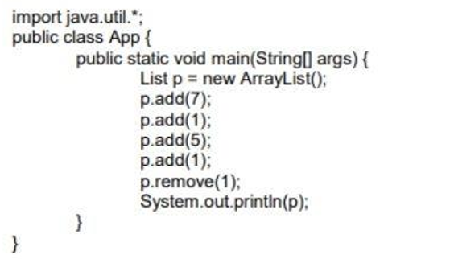
a) [7, 1, 5, 1]
b) [7, 5, 1]
c) [7, 5]
d) [ 7, 1]

Pregunta 2 (opción única)
What is the result?
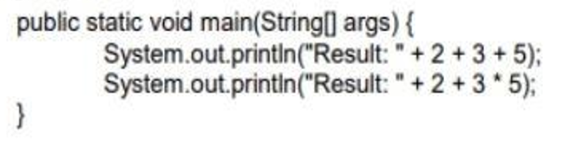
a) Result: 10 Result: 30
b) Result: 25 Result: 10
c) Result: 235 Result: 215
d) Result: 215 Result: 215
e) Compilation fails.

Pregunta 3 (opción única)
Whats is true about the class Wow?
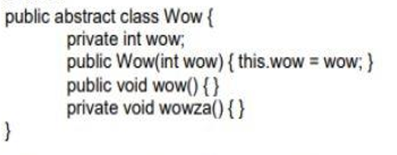
a) It compiles without error.
b) It does not compile because an abstract class cannot have private methods
c) It does not compile because an abstract class cannot have instance variables.
d) It does not compile because an abstract class must have at least one abstract method.
e) It does not compile because an abstract class must have a constructor with no arguments.

Pregunta 4 (opción única)
What is the result?
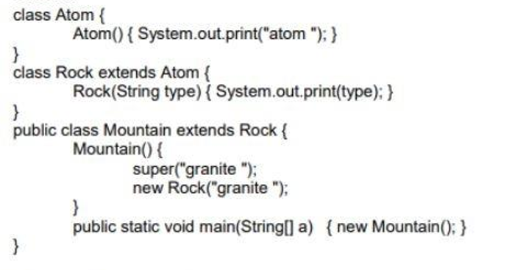
a) Compilation fails.
b) Atom granite.
c) Granite granite.
d) Atom granite granite.
e) An exception is thrown at runtime.
f) Atom granite atom granite.

Pregunta 5 (opción única)
What is the DTO pattern used for?
a) To implement the data access layer
b) To exchange data between processes
c) To implement the presentation layer.

Pregunta 6 (opción única)
What is printed out when the program is excuted?
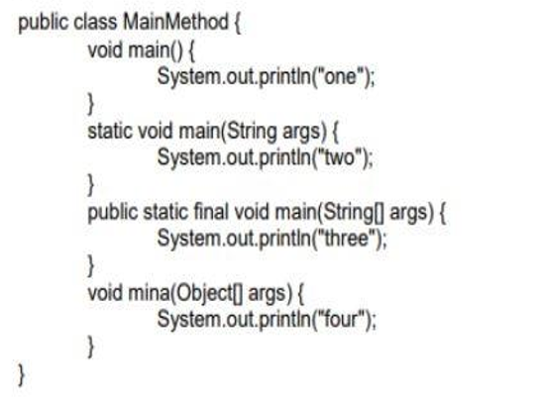
a) one
b) two
c) three
d) four
e) There is no output.

Pregunta 7 (opción única)
What is the result?
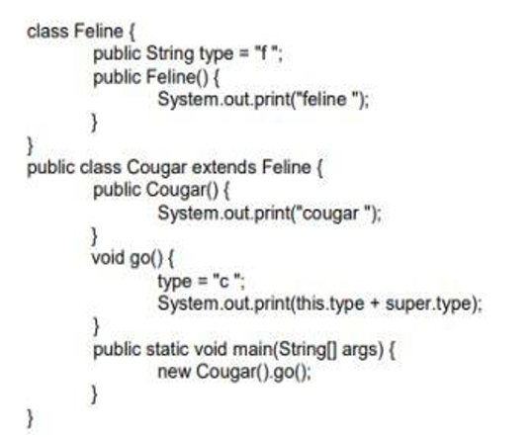
a) Cougar c f.
b) Feline cougar c c.
c) Feline cougar c f.
d) Compilation fails.

Pregunta 8 (opción única)
The pom.xml file is the configuration file For:
a) Ant
b) Gradle
c) Maven

Pregunta 9 (opción única)
What is the result?
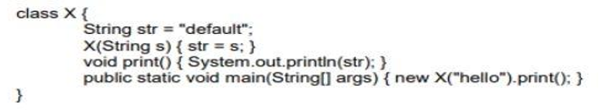
a) Hello
b) Default
c) Compilation fails.
d) The program prints nothing.
e) An exception is thrown at run time.

Pregunta 10 (opción única)
What is the result?
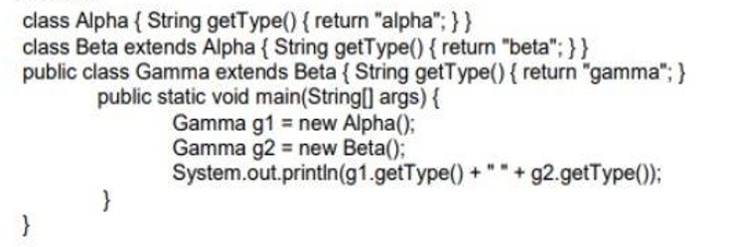
a) Alpha beta
b) Beta beta.
c) Gamma gamma.
d) Compilation fails.

Pregunta 11 (opción única)
What is the result?
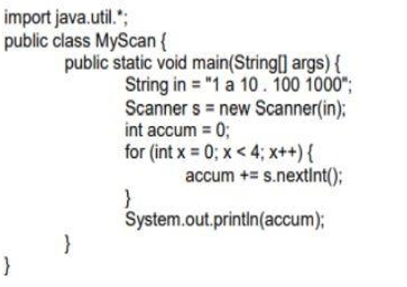
a) 11
b) 111
c) 1111
d) An exception is thrown at runtime.

Pregunta 12 (opción única)
What is the result?
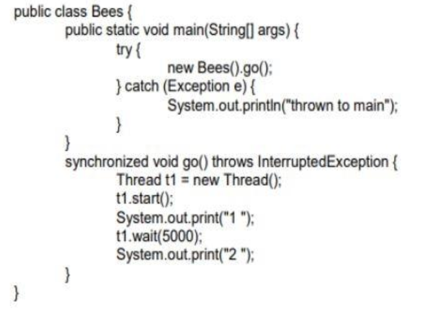
a) The program prints 1 then 2 after 5 seconds.
b) The program prints: 1 thrown to main.
c) The program prints: 1 2 thrown to main.
d) The program prints:1 then t1 waits for its notification.

Pregunta 13 (opción única)
What is the result?
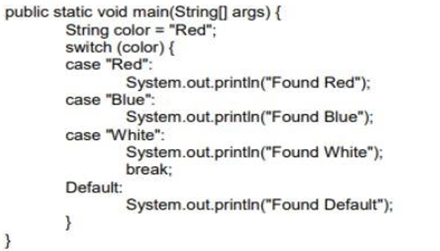
a) Found Red.
b) Found Red Found Blue.
c) Found Red Found Blue Found White.
d) Found Red Found Blue Found White Found Default.

Pregunta 14 (selección múltiple)
What is the result?
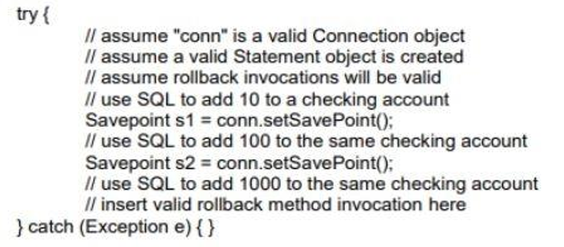
a) If conn.rollback(s1) is inserted, account will be incremented by 10.
b) If conn.rollback(s1) is inserted, account will be incremented by 1010.
c) If conn.rollback(s2) is inserted, account will be incremented by 100
d) If conn.rollback(s2) is inserted, account will be incremented by 110.
e) If conn.rollback(s2) is inserted, account will be incremented by 1110

Pregunta 15 (selección múltiple)
Which two declarations will compile?
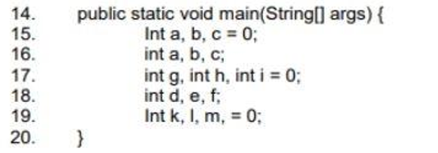
a) Line 15.
b) Line 16.
c) Line 17.
d) Line 18.
e) Line 19.
f) Line 20.

Pregunta 16 (opción única)
What will make this code compile and run?
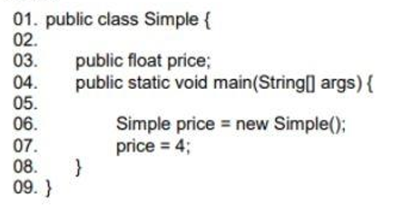
a) Change line 3 to the following: public int price;
b) Change line 7 to the following: int price = new Simple();
c) Change line 7 to the following: float price = new Simple ();
d) Change line 7 to the following: price = 4f;
e) Change line 7 to the following: price.price = 4;

Pregunta 17 (opción única)
Which statement is true?
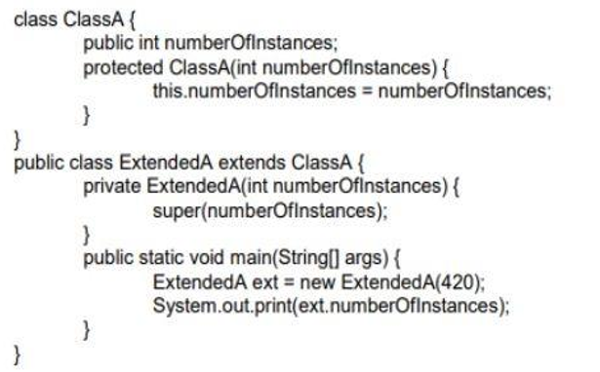
a) 420 is the output.
b) An exception is thrown at runtime.
c) All constructors must be declared public.
d) Constructors CANNOT use the private modifier.
e) Constructors CANNOT use the protected modifier.

Pregunta 18 (opción única)
The SINGLETON pattern allows:
a) Have a single instance of a class and this instance cannot be used by other classes
b) Having a single instance of a class, while allowing all classes have access to that instance.
c) Having a single instance of a class that can only be accessed by the first method that calls it.

Pregunta 19 (opción única)
What is the result?
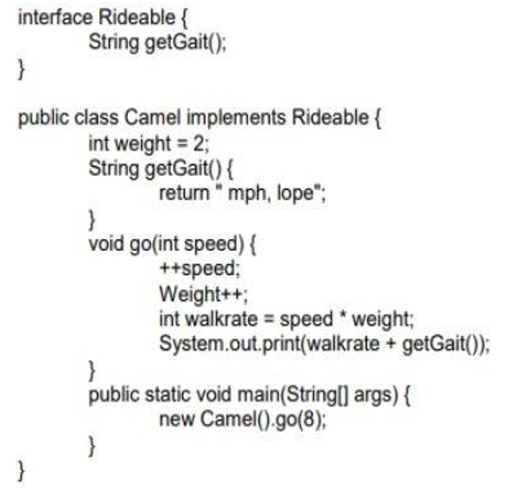
a) 16 mph, lope
b) 24 mph, lope.
c) 27 mph, lope.
d) Compilation fails

Pregunta 20 (opción única)
What is the result?
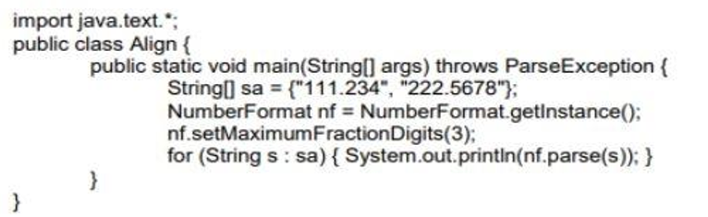
a) 111.234 222.567
b) 111.234 222.568
c) 111.234 222.5678
d) An exception is thrown at runtime.

Pregunta 21 (opción única)
Which is true?
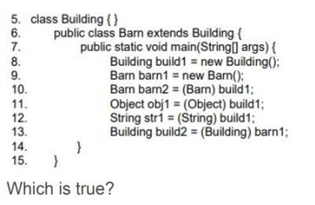
a) If line 10 is removed, the compilation succeeds.
b) If line 11 is removed, the compilation succeeds.
c) If line 12 is removed, the compilation succeeds.
d) If line 13 is removed, the compilation succeeds.
e) More than one line must be removed for compilation to succeed.

Pregunta 22 (selección múltiple)
Which two statements are true?
a) An abstract class can implement an interface.
b) An abstract class can be extended by an interface.
c) An interface CANNOT be extended by another interface.
d) An interface can be extended by an abstract class.
e) An abstract class can be extended by a concrete class.
f) An abstract class CANNOT be extended by an abstract class

Pregunta 23 (opción única)
What is the result?
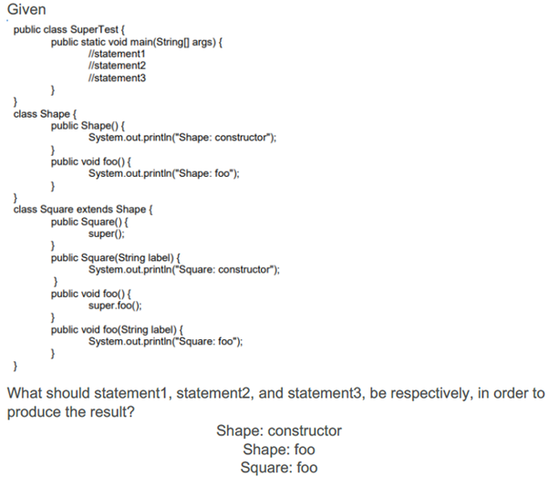
a) Square square = new Square ("bar"); square.foo ("bar"); square.foo();
b) Square square = new Square ("bar"); square.foo ("bar"); square.foo ("bar");
c) Square square = new Square (); square.foo (); square.foo(bar);
d) Square square = new Square (); square.foo (); square.foo("bar");
e) Square square = new Square (); square.foo (); square.foo ();

Pregunta 24 (opción única)
What changes will make this code compile?
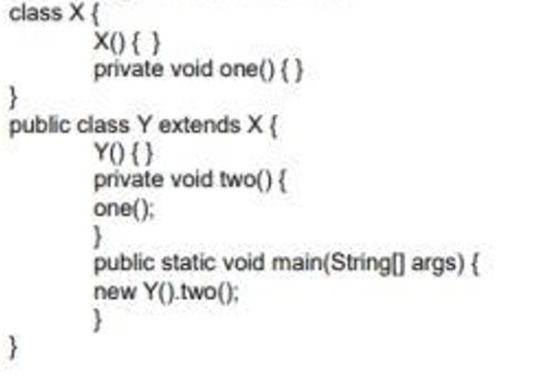
a) Adding the public modifier to the declaration of class X. (
b) Adding the protected modifier to the X() constructor.
c) Changing the private modifier on the declarationof the one() method to protected.
d) Removing the Y() constructor
e) Removing the private modifier from the two() method.

Pregunta 25 (opción única)
Which code fragment is illegal?
a) Class Base1 { abstract class Abs1 { } }
b) Abstract class Abs2 { void doit() { } }
c) class Base2 { abstract class Abs3 extends Base2 { } }
d) class Base3 { abstract int var1 = 89; }

Pregunta 26 (opción única)
What is the result?
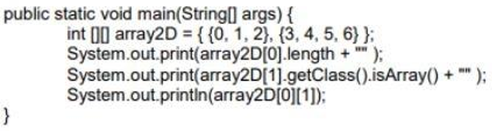
a) 3false1
b) 2true3
c) 2false3
d) 3true1
e) 3false3
f) 2true1
g) 2false1

Pregunta 27 (selección múltiple)
Which two possible outputs?
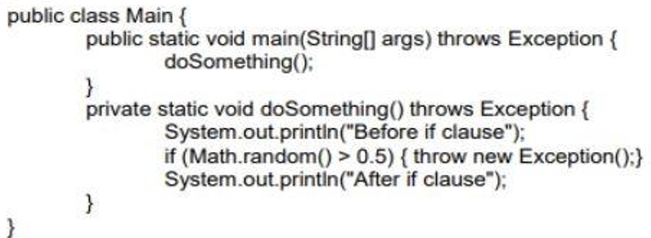
a) Before if clause Exception in thread "main" java.lang.Exception at Main.doSomething (Main.java:21) at Main.main (Main.java:15).
b) Before if clause Exception in thread "main" java.lang.Exception at Main.doSomething (Main.java:21) at Main.main (Main.java:15) After if clause.
c) Exception in thread "main" java.lang.Exception at Main.doSomething (Main.java:21) at Main.main (Main.java:15).
d) Before if clause After if clause.

Pregunta 28 (opción única)
What is the result if the integer value is 33?
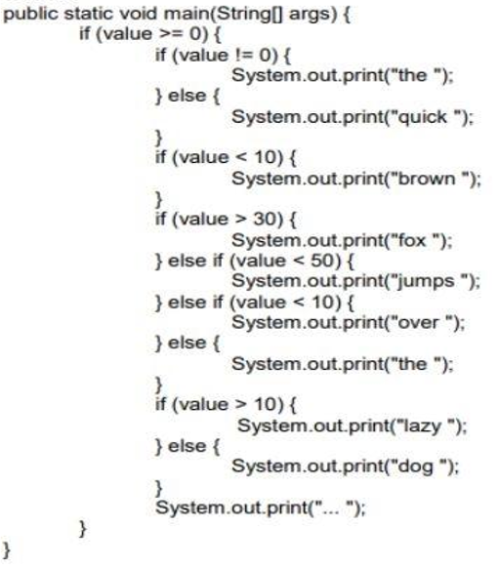
a) The fox jump lazy ?
b) The fox lazy ?
c) Quick fox over lazy ?

Pregunta 29 (selección múltiple)
Which three implementations are valid?
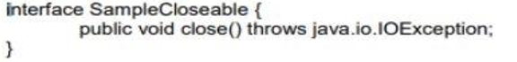
a) class Test implements SampleCloseable { public void close() throws java.io.IOException { // do something } }
b) class Test implements SampleCloseable { public void close() throws Exception { // do something } }
c) class Test implements SampleCloseable { public void close() throws FileNotFoundException { // do something } }
d) class Test extends SampleCloseable { public void close() throws java.io.IOException { // do something } }
e) class Test implements SampleCloseable { public void close() { // do something }}

Pregunta 30 (opción única)
What is the result?
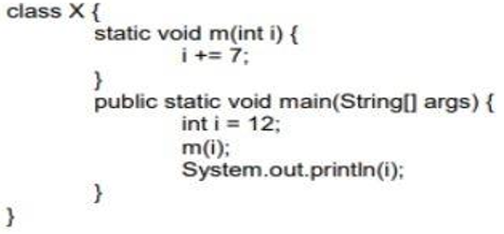
a) 7
b) 12
c) 19
d) Compilation fails.
e) An exception is thrown at run time

Pregunta 31 (opción única)
What is the result?
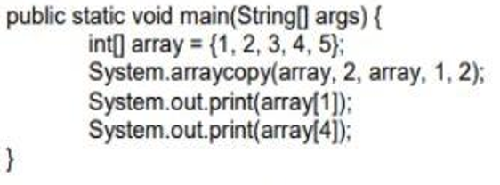
a) 14
b) 15
c) 24
d) 25
e) 34
f) 35

Pregunta 32 (opción única)
What is the result?
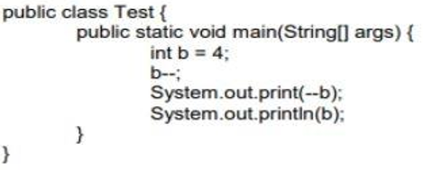
a) 22
b) 12
c) 32
d) 33

Pregunta 33 (selección múltiple)
Which three methods, inserted individually at line, will correctly complete class Two(Choose three)?
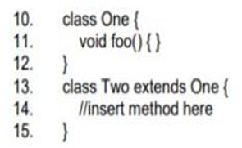
a) int foo() { /* more code here */ }
b) void foo() { /* more code here */ }
c) public void foo() { /* more code here */ }
d) private void foo() { /* more code here */ }
e) protected void foo() { /* more code here */ }

Pregunta 34 (opción única)
What is the result?
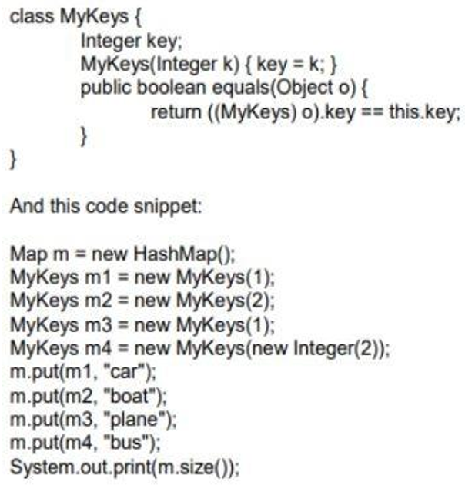
a) 2
b) 3
c) 4
d) Compilation fails.

Pregunta 35 (opción única)
What is the result?
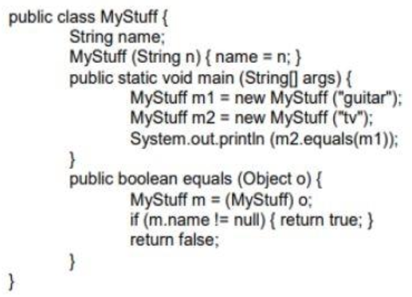
a) The output is true and MyStuff fulfills the Object.equals() contract
b) The output is false and MyStuff fulfills the Object.equals() contract
c) The output is true and MyStuff does NOT fulfill the Object.equals() contract.
d) The output is false and MyStuff does NOT fulfill the Object.equals() contract

Pregunta 36 (opción única)
What is the result?
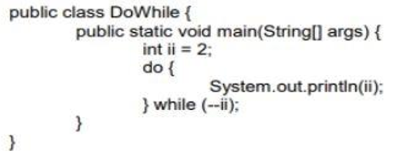
a) 2 1 2
b) 1 0
c) null
d) An infinite loop.
e) Compilation fails

Pregunta 37 (opción única)
In the Java collections framework a Set is:
a) A collection that cannot contain duplicate elements.
b) An ordered collection that can contain duplicate elements
c) An object that maps value key sets and cannot contain values Duplicates

Pregunta 38 (opción única)
Whats is the result?
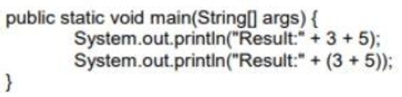
a) Result: 8 Result: 8
b) Result: 35 Result: 8
c) Result: 8 Result: 35
d) Result: 35 Result: 35

Pregunta 39 (opción única)
Which statement, when inserted into line '' // TODO code application logic here", is valid in compilation time change?
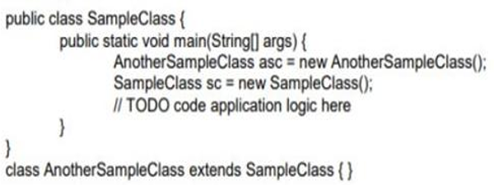
a) asc = sc;
b) sc = asc;
c) asc = (Object) sc;
d) asc= sc.clone();

Pregunta 40 (opción única)
What value of x, y, z will produce the following result? 1234,1234,1234 -----, 1234, ------
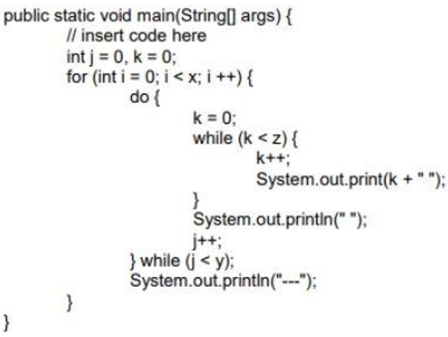
a) int x = 4, y = 3, z = 2;
b) int x = 3, y = 2, z = 3;
c) int x = 2, y = 3, z = 3;
d) int x = 4, y = 2, z= 3;
e) int x = 2, y = 3, z = 4;

Pregunta 41 (opción única)
What changes will make this code compile?
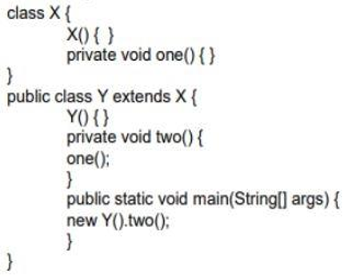
a) Adding the public modifier to the declaration of class X.
b) Adding the protected modifier to the X() constructor.
c) Changing the private modifier on the declarationof the one() method to protected.
d) Removing the Y() constructor.

Pregunta 42 (selección múltiple)
Which three are valid? (Choose three)
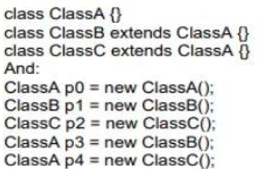
a) p0 = p1;
b) p1 = p2;
c) p2 = p4;
d) p2 = (ClassC)p1;
e) p1 = (ClassB)p3;
f) p2 = (ClassC)p4;

Pregunta 43 (opción única)
What is the result?
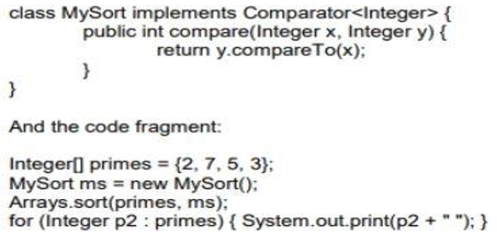
a) 2 3 5 7
b) 2 7 5 3
c) 7 5 3 2
d) Compilation fails.

Pregunta 44 (selección múltiple)
Which three lines will compile and output "Right on!"?
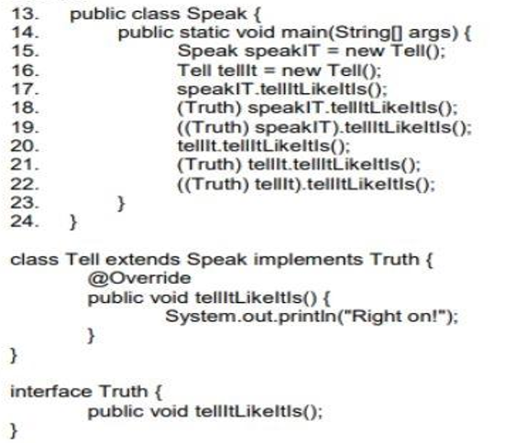
a) Line 17
b) Line 18
c) Line 19
d) Line 20
e) Line 21
f) Line 22

Pregunta 45 (opción única)
What is the result?
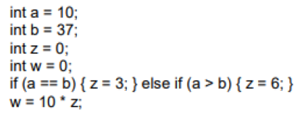
a) 0
b) 30
c) 60

Pregunta 46 (opción única)
Which one is valid as a replacement for foo?
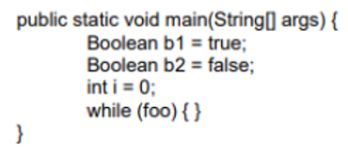
a) b1.compareTo(b2)
b) i = 1
c) i == 2? -1:0
d) foo.equals("bar")

Pregunta 47 (selección múltiple)
Which three options correctly describe the relationship between the classes?
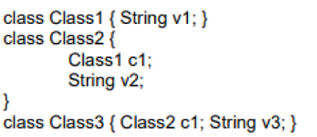
a) Class2 has-a v3.
b) Class1 has-a v2.
c) Class2 has-a v2.
d) Class3 has-a v1.
e) Class2 has-a Class3.
f) Class2 has-a Class1.

Pregunta 48 (opción única)
What is the result?
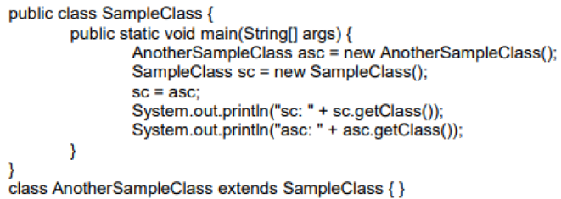
a) sc: class.Object asc: class.AnotherSampleClass
b) sc: class.SampleClass asc: class.AnotherSampleClass
c) sc: class.AnotherSampleClass asc: class.SampleClass
d) sc: class.AnotherSampleClass asc: class.AnotherSampleClass

Pregunta 49 (opción única)
How many times is 2 printed?
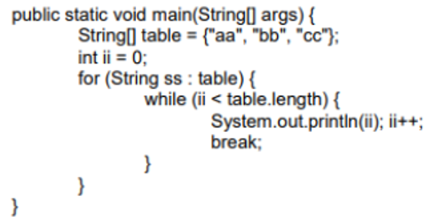
a) Zero.
b) Once.
c) Twice.
d) Thrice.
e) It is not printed because compilation fails.

Pregunta 50 (opción única)
In Java the difference between throws and throw Is:
a) Throws throws an exception and throw indicates the type of exception that the method.
b) Throws is used in methods and throw in constructors.
c) Throws indicates the type of exception that the method does not handle and throw an exception.

Pregunta 51 (opción única)
What is the result?
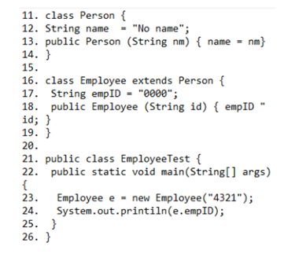
a) 4321.
b) 0000.
c) An exception is thrown at runtime.
d) Compilation fails because of an error in line 18.

Pregunta 52 (opción única)
What is the result?
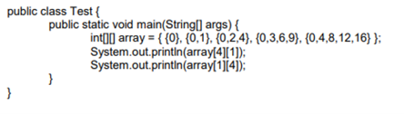
a) 4 Null.
b) Null 4.
c) An IllegalArgumentException is thrown at run time.
d) 4 An ArrayIndexOutOfBoundsException is thrown at run time.

Pregunta 53 (opción única)
What is the result?
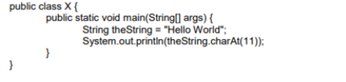
a) There is no output.
b) d is output.
c) A StringIndexOutOfBoundsException is thrown at runtime.
d) An ArrayIndexOutOfBoundsException is thrown at runtime.
e) A NullPointException is thrown at runtime.
f) A StringArrayIndexOutOfBoundsException is thrown at runtime.

